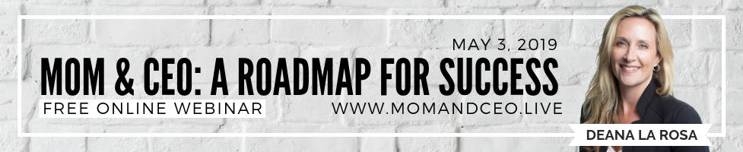NEWSLETTER BLURB & SOCIAL MEDIA POSTS

Newsletter Blurb:

My friend, Deana La Rosa, Mom & CEO, business and personal Coach, is hosting a free online video interview series called Mom & CEO, A Roadmap for Success, for anyone who wants to transition to a time and financial freedom lifestyle where they can run their own business while their family is Thriving or curious to learn more. I’m thrilled to be one of the 21 hand-picked influencers interviewed for this empowering event. Gain access to these truly educational, inspiring conversations and gain a new perspective about how you can manage both and live a life that you have dreamed of, as each influencer helps shift you into action to have a MONUMENTAL change in YOUR own LIFE! This is an amazing opportunity to not only obtain valuable insight, but profound personal experiences, and practical tips that will significantly advance you in the pursuit of Fulfilment in both Career and Family! I invite you to join me and gain access to this exciting online event. >>AFFILIATE LINK<<

Facebook: Join me as I am interviewed by Deana La Rosa, Mom & CEO, host of the “Mom & CEO, A Roadmap for Success” video series, where we discuss, #buildingabusiness options and solutions to help you have a MONUMENTAL change in YOUR LIFE! You don’t want to miss this. Gain FREE access to this exciting and educational video series here… >>AFFILIATE LINK<<

Twitter: Watch my interview with Deana La Rosa, Mom & CEO as we discuss #startingabusiness for the #momandceoaroadmapforsuccesssummit #momandceo #womeninbusiness #thriveinbusinessandfamily #poweredbywomen #deanalarosa >>AFFILIATE LINK<<

Instagram: Join me as I am interviewed by Deana La Rosa! In her #momandceoaroadmapforsuccesssummit –– Video Interview Series –– we discuss #startingabusiness #thrivingfamily options so you can have a MONUMENTAL change in your OWN LIFE having Time and Financial FREEDOM while having a POSITIVE impact on YOUR FAMILY! >>AFFILIATE LINK<<

#startingabusiness #momandceoaroadmapforsuccesssummit #momandceo #womeninbusiness #thriveinbusinessandfamily #poweredbywomen #deanalarosa #thrivingfamily

