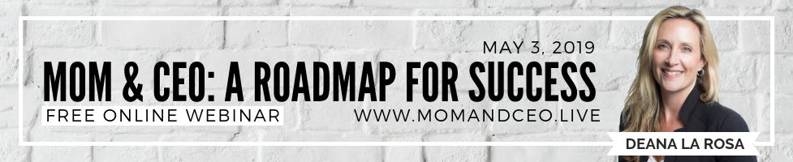

SOLO EMAIL 1

BE SURE TO INCLUDE YOUR PERSONAL AFFILIATE LINK FOR TRACKING.

Subject: Ready for change?

Dear (Name),

Because you are important to me I knew you'd want to see this.

My friend/colleague Deana La Rosa has put together this powerful interview series, Mom & CEO, A Roadmap for Success Summit, featuring 21 experts (including me!) who are sharing their personal breakthroughs and transformations around building their own business while their family Thrives and how it has transformed their life.

Wait until you hear some of these amazing stories of transformation!

The interviews are about 30 minutes long, and you can listen from anywhere!

The most important steps I ever took towards completely transforming my life was building a business and becoming my own boss. I talk about it in this interview. I know the same goes for the other 20 experts who share their stories. This interview series has the power to change your life.
Grab your free spot by clicking this link >>AFFILIATE LINK <<
You’re also going to get free gifts – from some of the speakers, so you can begin to take action right away to build your new business and family lifestyle.

I really want to support you in feeling empowered to create what I know you want for you, your family, and your legacy.

This is your opportunity to access this free life changing series. Visit [AFFILIATE LINK] to get access now!

With Love and Gratitude,
YOUR SIGN OFF

Here’s that link again. >>AFFILIATE LINK<<

